Trained DATA SET

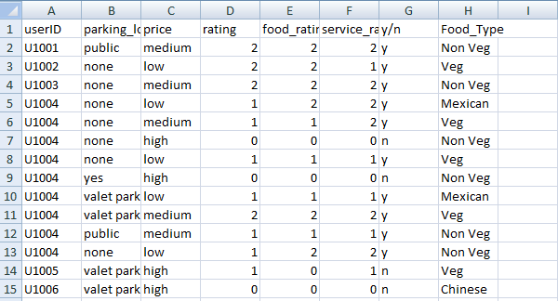

TEST DATA SET

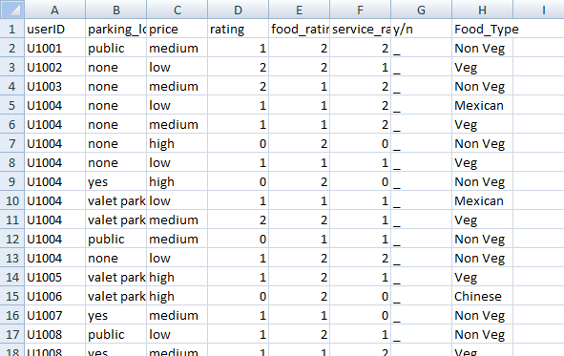

AFTER APPLYING MACHINE LEARNING J48 or DECISION TREE USING WEKA

RESULT PREDICTION RESULT

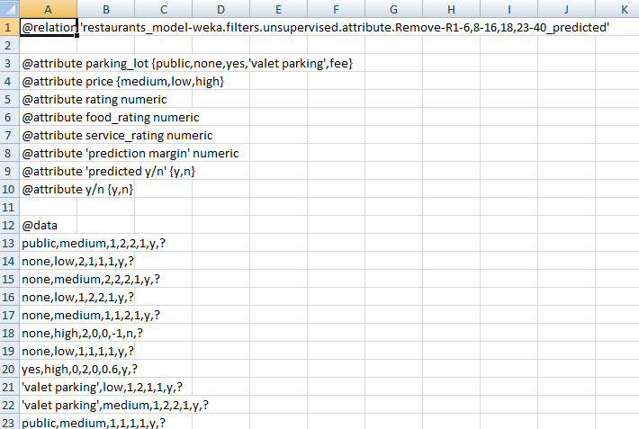

Converted TO DATASET

